 | "Empowerment through quality technical education" AJEENKYA DY Patil School of Engineering  Dr. D. Y. Patil Knowledge City, Charholi Bk., Via. Lohegaon, Pune-412105.  Dep artment of Artificial Intelligence and Data Science Engineering
ACADEMIC YEAR : 2025-26
SUBJECT: Database Management Systems (PCC-251- AID)
CLASS: SE-B |  | SEMESTER: IV
TITLE OF MINI PROJECT: Design & Implementation of a Hospital Management System Using SQL
ROLL NO: |  | NAME OF STUDENT:
56 |  | Janvi Subhash Pawar
59 |  | Sakshi Sunil Pawar
40 |  | Aarvee Vijay Nimbalkar
16 |  | Nikita Shankar Lahane
NAME AND SIGN OF SUBJECT INCHARGE: Prof. Supriya Survase

TITLE OF MINI PROJECT - Hospital Management System Using MySQL with Automated Billing
Introduction-
A Hospital Management System (HMS) is essential for maintaining accurate and efficient records of patients, doctors, appointments, treatments, and billing. This project demonstrates how database concepts such as tables, constraints, joins, triggers, and stored procedures can be used to build a functional and automated hospital database system. The system ensures faster data retrieval, reduced manual errors, and improved workflow in hospital operations.
Problem Statement –
Hospitals handle large volumes of data daily, including patient details, doctor schedules, appointments, treatments, and billing. Manual record-keeping often leads to errors, delays, and difficulty in retrieving information. There is a need for a structured and automated system that can store, manage, and process hospital data efficiently.
This project aims to design and implement a Hospital Management System using MySQL that automates billing, maintains accurate records, and provides quick access to essential information.
Implementation -
Include:
1. Database Creation
- Creation of database HOSPITAL_RECORD

2. Table Creation
- Patient
- Doctor
- Appointment
- Treatment
- Bill
3. Data Insertion
- 5 sample patients
- 5 sample doctors
- 5 appointments
- 5 treatments

4. Trigger
- trg_generate_bill to auto-generate bills when appointment status becomes Completed
5. Stored Procedure
- GetPatientDetails to fetch patient + appointment details

6. SQL Queries
- Joins
- Aggregation
- Reports
• Input/output snapshots (screenshots or console output)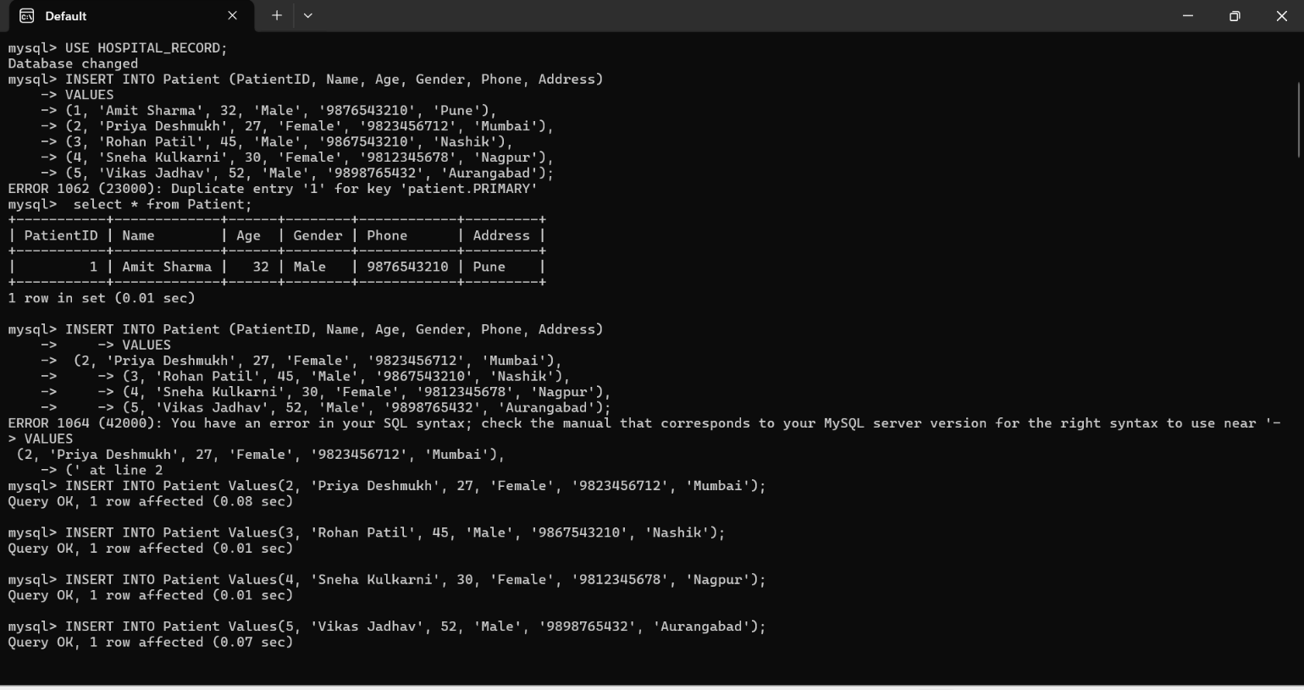
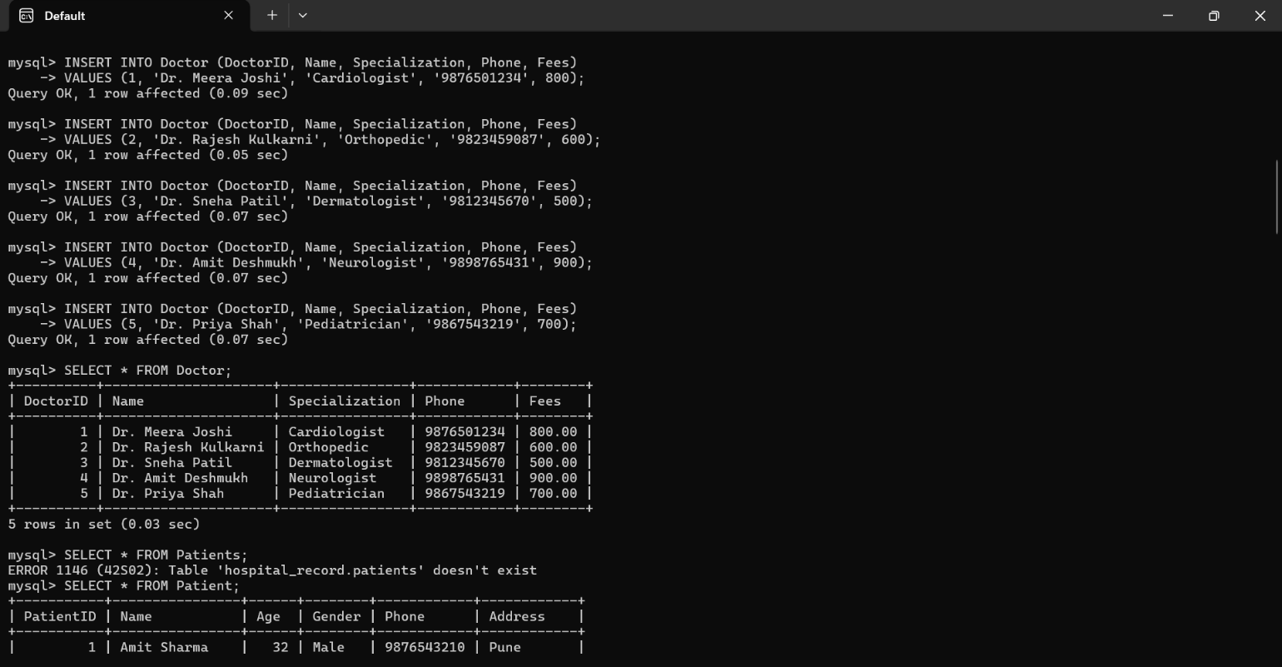
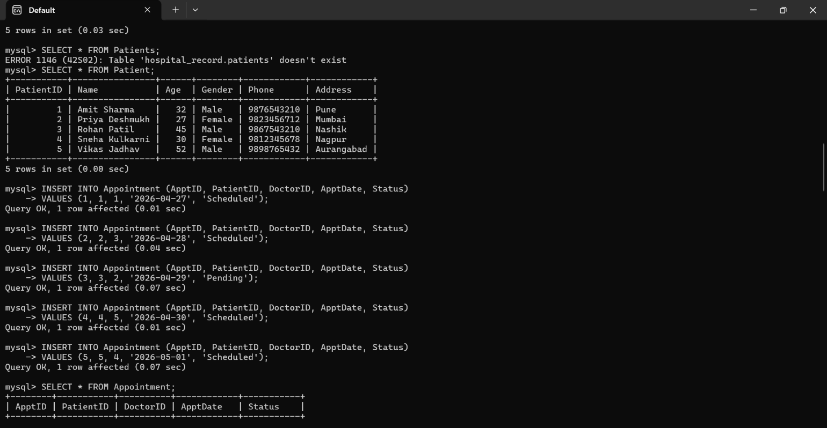
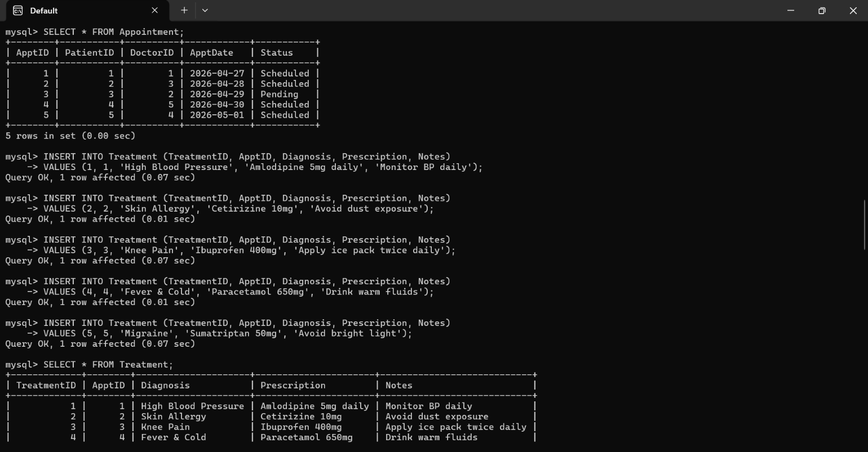
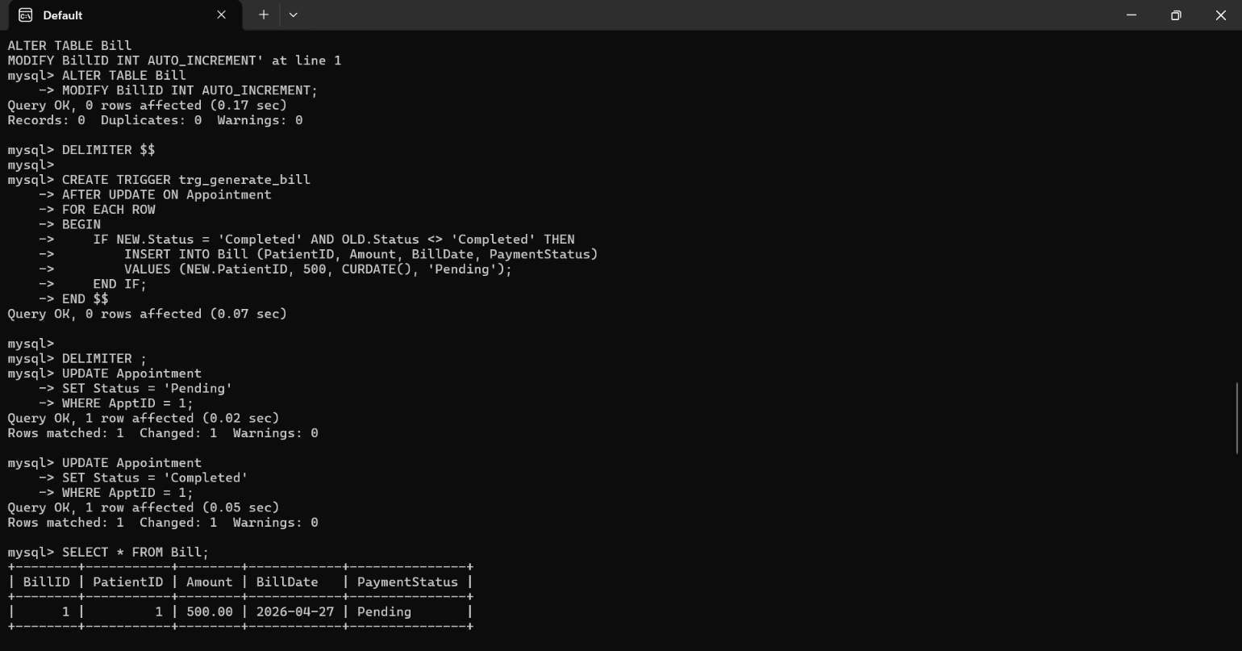
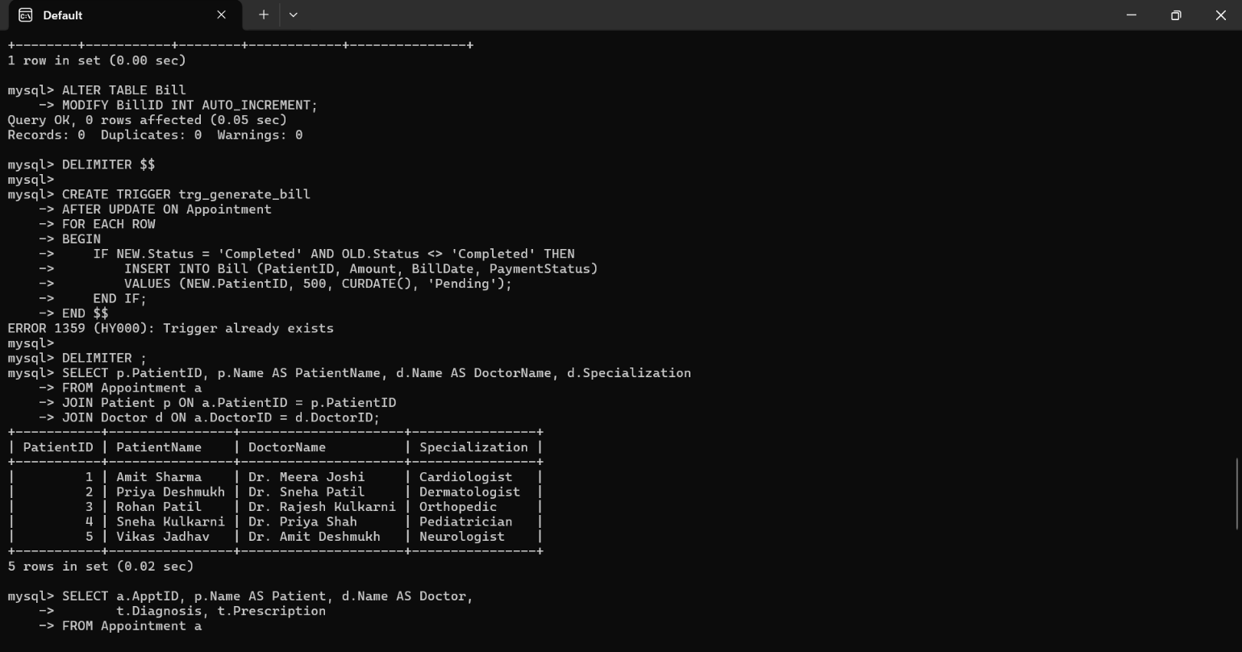
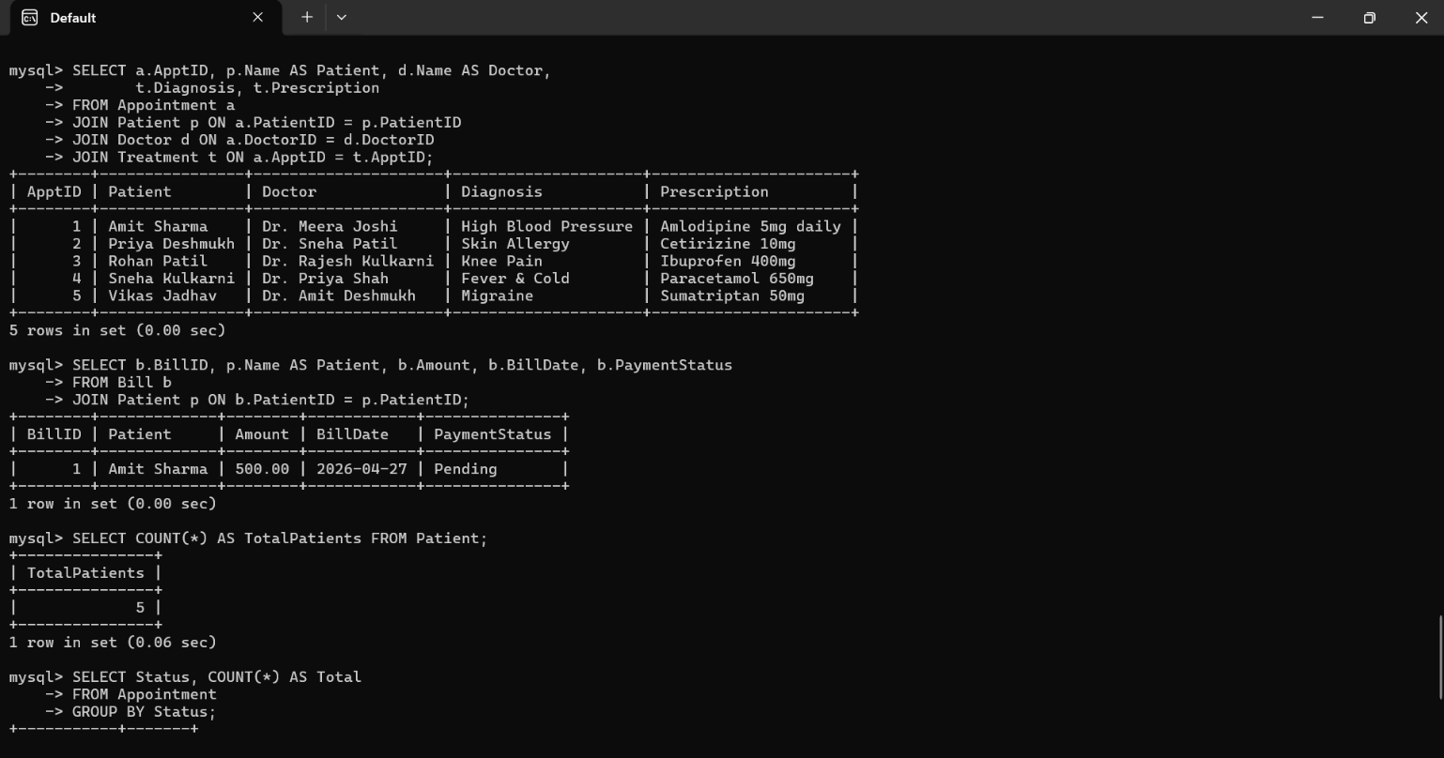
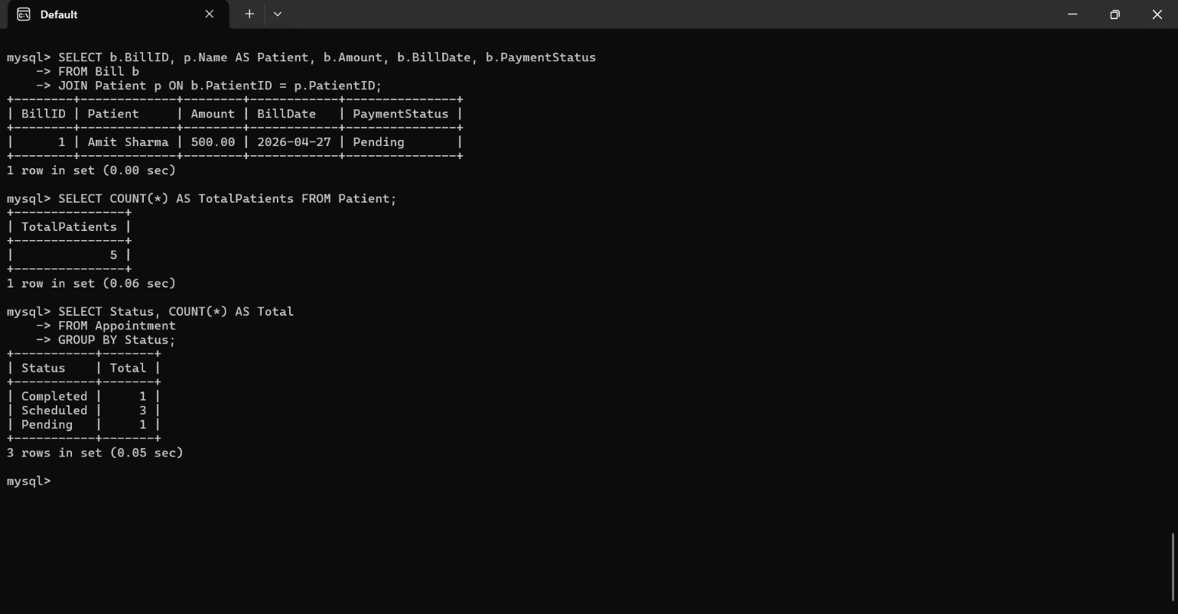
Advantages and Limitations-
Advantages
- Automates billing using triggers
- Reduces manual errors
- Fast and accurate data retrieval
- Easy to maintain and update
- Ensures data integrity using constraints
- Real-world hospital workflow simulation
Limitations
- No frontend interface (CLI only)
- Limited to basic hospital operations
- No authentication or user roles
- No advanced analytics
Future Scope-
- Add a web or mobile frontend
- Implement login system with roles (Admin, Doctor, Receptionist)
- Add NoSQL (MongoDB) for unstructured data
- Integrate payment gateway
- Add appointment reminders via SMS/email
- Add dashboards for analytics

Conclusion-
The Hospital Management System successfully demonstrates how MySQL can be used to design and implement a structured, automated, and efficient database system. Using triggers, stored procedures, and SQL queries, the system reduces manual effort, improves accuracy, and provides quick access to essential hospital information. This project highlights the importance of database management in real-world applications.
References-
- MySQL Documentation
- DBMS Textbooks
- Online SQL Tutorials
- Classroom Notes

